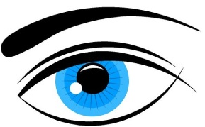
Baker Vision Care
31 South 6th Street, Macclenny, FL 32063 904-259-6259
Red/Irritated Eye Description page

Right Eye Left Eye
□Redness

□Itching

□Swelling

□Burning

□Trauma

□Pain

□Blur (decrease in vision)

□Spots, flashes and floaters

□None

□Other:
________________________________________________________________________________________________________________________

□Redness

□Itching

□Swelling

□Burning

□Trauma

□Pain

□Blur (decrease in vision)

□Spots, flashes and floaters

□None

□Other:
________________________________________________________________________________________________________________________

